ANNEX 4
Proposals to improve Queen Street 2009

The original proposals and the changes to them are illustrated on Plan 1 below.

Original proposals

Relocation of bus stops away from Queen Street
Bus stops currently in Queen Street will be moved to the northern end of St Aldate’s, the northern end of Castle Street and New Road, just west of Bonn Square. New stops will be created in Castle Street east (M2 and M3) next to the Westgate Centre, New Road south (E5) outside County Hall, west of Bonn Square in New Road (D5) and on High Street north side, immediately east of its junction with Turl Street (U1). St Aldate’s stop G5 (at the very northern end of the west side of the street) is proposed to be removed to ease pavement congestion. All of these stops can be seen on the map accompanying the bus stop allocation proposals at the end of this annex. The bus stop allocation proposals set out which buses serve the new and existing stops.

Reduction of bus flows on Queen Street
The original proposals to reallocate bus stops away from Queen Street resulted in a reduction in the number of buses passing through Queen Street from 76 to 44 an hour.

Creating more space for pedestrians
Because buses will no longer stop in the street, the carriageway can be reduced to 6m wide allowing the provision of wider pavements along the street. The 6m carriageway will still allow the remaining buses to pass delivery vehicles (allowed in the street before 10am and after 6pm) without having to mount the pavement

Resurfacing pavements and the road
To improve the appearance of the street the existing surface materials will be replaced. At Carfax, pavements on both sides of the road from the junction with High Street as far as the western edge of the “square” at the Crabtree & Evelyn shop will be replaced with the same York stone as used on Cornmarket Street and High Street. Westwards from that point as far as the junction of New Road and castle Street, the current paving slabs will be replaced with a new flexible surfacing material, likely to be a coloured tarmac to match the York stone. This material will extend to cover the area in front of the Westgate shopping centre main entrance.

To complement the improved pavement surface, the carriageway will be resurfaced using the same material as in Cornmarket Street. In keeping with this, the same wide black granite kerbs/channels as in Cornmarket Street will be used at the edge of the carriageway.

Replacing street furniture - benches, cycle racks etc
Much of the street furniture in Queen Street is of mixed quality and in many cases in poor condition. It is also not necessarily appropriately located. For example, the area of paving at Carfax on the south side of the road is often very busy with pedestrians whose path is obstructed by amongst other things seating, a hanging basket pole and litter bin. A proper audit of all of the street furniture in the street will be undertaken as part of the scheme. Opportunities will be taken to remove unnecessary street furniture and replace the remaining pieces with higher quality, better located ones. It is also acknowledged that demand significantly outstrips supply for cycle parking and new and additional locations will be sought. As will locations for seating.

Bus shelters
In order to ensure the best possible waiting environment for those bus passengers who will be relocated away from Queen Street, it is proposed as part of the scheme to replace all of the shelters in St Aldate’s (east) and Castle Street (east and west). The new shelters will be of the type that is included (for use in conservation areas) in the contract between the city council and advertising shelter provider Clear Channel UK: i.e. “Landmark shelters”. The main body of the shelter will be the same as those provided as part of the contract in Queen Street (i.e. stainless steel and glass), but the roof type will be the “Plate” type which is clear glass and is considered by county and city planning and conservation officers to be more suitable in the sensitive city centre conservation area.

Shelters will not be provided at D4, D5 and U1 due to space constraints on the pavement and conservation reasons.

Recommended changes to the proposals in response to consultation

Improvements to the pavements in Castle Street

Consultees were concerned that the new bus stopping areas would be unattractive for bus passengers. Particular mention was made of the narrow and uneven pavement on the west side of Castle Street.

As part of the preparatory work for the scheme, this pavement will be improved to provide a better waiting environment.

Improvements to subway ramps

Consultees were concerned that the walking routes to/from bus stops in Castle Street would be unattractive, particularly the route to the east side which involves using the subway ramps (not the subway itself).

The subway ramps will be improved to provide a more attractive route. Lighting will be repaired if necessary.

Additional seating in Queen Street to mitigate the walking distances

Consultees were concerned about the additional walking distances to bus stops. Extra seating will be provided in Queen Street and near bus stops in Castle Street (on the east side) to provide resting places for those less able to walk.

Zebra crossing

Consultees were concerned that it would be difficult to cross the road to reach the bus stops on the west side of Castle Street. The subway was not considered an attractive option for crossing here.

A zebra crossing is proposed at the junction of New Road and Castle Street (see Annex 7). This crossing, together with the proposed widening of the pavement on the south side of New Road, will provide a safe and convenient route to the bus stops of the west side of Castle Street and the south side of New Road, as well as for pedestrians heading west towards the station. The zebra crossing would replace the existing puffin crossing outside County Hall.

Reinstatement of stop H1 for service 300

Consultees were concerned that Park & Ride service 300 could not use the proposed stop (M1) because it is routed in a way that would prevent it accessing this stop on Saturdays. It would be very confusing if passengers had to use a different stop on Saturdays.

This stop has been reinstated in St Aldate’s at its current position (H1) in the revised allocation.

Additional cycle parking

Cyclists called for additional cycle parking to be provided as part of this scheme.

Additional cycle parking is being investigated at the very southern end of Cornmarket Street and at the west end of Queen Street, at its junction with St Ebbe’s and New Inn Hall Street.

Narrowing of entry to Queen Street

Consultees were concerned that bus speeds would increase in Queen Street as a result of this scheme.

Officers do not believe this will be a problem (see Annex 5 – road safety assessment). However, to help ensure bus drivers keep their speeds down, any additional cycle parking at the west end of Queen Street (see above) will be arranged to narrow the carriageway on entry to Queen Street.

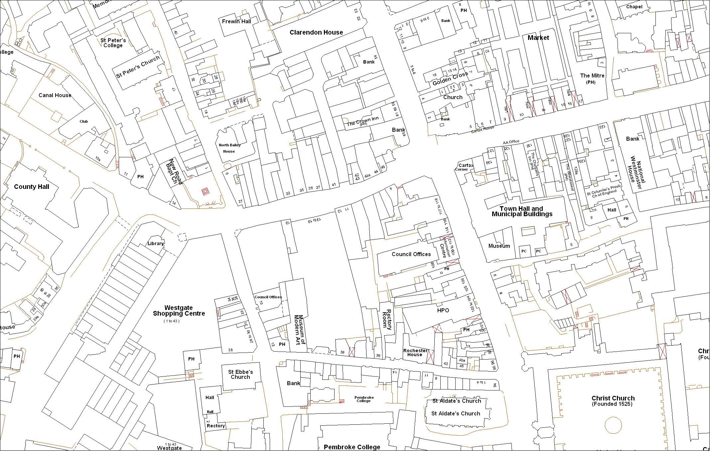
Plan 1 – main changes to street design and layout
Queen Street
- Bus stops and shelters removed
- Pavements widened to reduce carriageway to 6 metres wide
- New street surfaces throughout
- York stone on pavements at Carfax, buff surfacing on footways elsewhere
- New street furniture
- New seating at Carfax and point A*
- Declutter
New Road/Bonn Square
- Extra bus stop added on south side
- New zebra crossing at point B*
- Puffin crossing removed from point C
- Pavement widened at point D
- Extra bus stop added on north side
- East of point E, same pavement and carriageway surfacing as Queen Street
A
E
B
St Aldate’s
- New bus shelters at all stops on west side
- Bus stop G5 removed (currently at point F) to ease pavement congestion
- Bus stop G4 rearranged to increase pavement space (point G)
- Declutter
High Street
- New bus stop on north side

C
D
F

G

Castle Street
- New bus shelters at all stops
- New zebra crossing at point B*
- Subway ramps on east side to be imrpoved*
- Two extra bus stops created on east side
- Bus lay-by extended on east side
- New seating near bus stops*
- West side pavements improved*

Key
Existing bus stops
New bus stops

Changes to proposal in response to consultation

*



Improvements to Queen Street – summer 2009

Proposed bus stop locations

The table below shows the proposed new bus stop locations for buses serving the city centre. These changes are part of our proposals to relocate the bus stops from Queen Street to improve the street for pedestrians. For more details please see www.oxfordshire.gov.uk/transformoxford

Most of the changes are in the Queen Street area. Most buses departing from other parts of the city centre will continue to use their current stop.

The table below must be read alongside the bus stop map at the end of the table, which shows the locations of all city centre bus stops (including proposed new stops).

If you cannot find your bus service or need any other information, please call us on 01865 815807.

We want to hear your views on the proposed bus stop locations.

You can contact us in one of the following ways to find out more about our proposals and tell us what you think of them:

- Visit the website: www.oxfordshire.gov.uk/transformoxford
- Write to Queen Street Proposals, FREEPOST OXFORDSHIRE, COUNTY COUNCIL (no further address required)
- Email transformoxford@oxfordshire.gov.uk
Proposed bus stops locations
 |  | Where to catch your bus in the city centre (outbound travel) |  | Where to get off your bus in the city centre (inbound travel)
Service | Destinations | Current stops | Proposed  new stops | Current stops | Proposed new stops
1/N1 | Cowley Centre, Blackbird Leys | F7, K1 | G4, K1 | J3, I3, S1 | No Change
2 group | Summertown, Kidlington | C1 | No Change | T1 | No Change
3 | Rose Hill | F7, K2 | E2, K2 | J3, I3, S1 | No Change
4 group to/from Rose Hill | Rose Hill | R7, D1, F3, K2 | R7, D1, M1, K2 | J2, I1, S1, E3, E6, R10 | J2, I1, S1, E5, E6, R10
4 group to/from Botley | Abingdon via Wootton, Dalton Barracks, Botley, Fridewide Square, Cumnor, Elms Rise, Dean Court. | J2, I1, S1, E3, E6, R10 | J2, I1, S1, E5, E6, R10 | R7, D1, F3, K2 | R7, D1, M1, K2
5 | Rail Station, Cowley Centre, Blackbird Leys | R2, R7, D1, F4, K1 | R2, R7, D1, M3, S2, G3, K1 | J4, I2, S1, E2, E6, R10, R2 | J4, I2, S1, E1, E6, R10, R2
6 | Wolvercote | C4 | No Change | T1 | No Change
7A/7B | Summertown, Kidlington | C2 | No Change | T1 | No Change
7C | Brookes Uni - Headington Campus, Headington, Barton | F1, K4 | D4, K4 | J4, I3, S1 | No Change
8&9 | Brookes Uni -Headington Campus, Headington, , Barton/Risinghurst | F2, K4 | D5, K4 | J4, I3, S1 | No Change
10 | Cowley Centre, Wood Farm, Nuffield Hospital, John Radcliffe Hospital | F7, K1 | G1, K1 | J4, I3 | No Change
U10 | Cowley Centre, John Radcliffe Hospital, Nuffield Hospital, Wood Farm. | F1, K1 | G1, K1 | J4, I3 | No Change
 |  | Where to catch your bus in the city centre (outbound travel) |  | Where to get off your bus in the city centre (inbound travel)
Service | Destinations | Current stops | Proposed  new stops | Current stops | Proposed new stops
11 | Botley, Eynsham, Farmoor, Long Hanborough, Freeland, North Leigh, Witney | E1, E6, R9 | E4, E6, R9 | R8, D3, M1 | R8, D3, M2
12/12B/12C | Cowley Centre, Oxford Business Park, Blackbird Leys, Greater Leys | F1, K2 | G1, K2 | J4, I3 | No Change
13 | Rail Station, Marston, Northway, John Radcliffe Hospital, Rail Station | R1, R7, D1, M1, S2, G3, K3 | R1, R7, D1, M3, S2, G2, K3 | J4, I3, S1, E3, E6, R10, R1 | J4, I2, S1, E1, E6, R10, R1
X13 to/from Abingdon | Abingdon | J4, I2, H3, P1 | No Change | P2, G3, K3 | P2, G2, K3
X13 to/from John Radcliffe Hospital | Marston, Northway, John Radcliffe Hospital | P2, G3, K3 | P2, G2, K3 | J4, I2, H3, P1 | No Change
14/14A | Rail Station, Cherwell Scholl, Marston, John Radcliffe Hospital | R5, R8, B1, C2 | No Change | A1, A5, E6, R9, R5 | No Change
15 | Churchill Hospital, Nuffield Hospital, Wood Farm. | S2, G5, K3, | E3, K3 | J4, I3, S1 | No Change
16 | Florence Park, Cowley Centre, Minchery Farm | H2, P1 | No Change | P2, E3, D4, H2 | P2, E1
17 | Jericho, Cutteslowe | E4, B1, C4 | No Change | A1, A5, E6, E1 | A1, A5, M2
17A | Jericho, Marston, John Radcliffe Hospital | R5, B1, C4 | No Change | A1, A5, E6, R5 | No Change
N17 | Headington, Barton | F1, K1 | D4, K4 | J1, I | No Change
18, 18A | Woodstock Road, Cassington, Eynsham, Standlake, Stanton Harcourt, Northmoor, Standlake, Bampton, Clanfield. | B1, B2 | No Change | A1, A5 | No Change
 |  | Where to catch your bus in the city centre (outbound travel) |  | Where to get off your bus in the city centre (inbound travel)
Service | Destinations | Current stops | Proposed  new stops | Current stops | Proposed new stops
25/25A | Oxford Rail Station, Kidlington, Bletchingdon, Kirtlington, Lower Heyford, Middleton Stoney, Weston-on-the-Green, Wendlebury, Bicester | Bus Station Bay 12, C4 | No Change | T1, Bus Station Bay 12, R6 | No Change
X30 | Botley, Cumnor, East Hanney, Grove, Wantage | H4, E3, E6, R9 | No Change | R8, D3, F1 | R8, D3, H4
31/34 | Bagley Wood, Abingdon, Marcham, East Hanney, Grove, Wantage, Drayton, Steventon, Harwell. | J4, H4, P1 | No Change | P2, G4, K3 | P2, E1
X32 | Didcot, Harwell Village, Rowstock Corner, Harwell Science Campus (IBC), Chilton | H5, P1 | No Change | P2, E1 | No Change
35/35A | Kennington, Radley, Abingdon, Drayton, Steventon, Milton Park, Didcot | J4, H2, P1 | No Change | P2, G4, G5, K3 | P2, E1
44 | Boars Hill, Sunningwell, Abingdon. | AM Route: R8, D3, M1, P1  PM Route: P2, E1, E6, R9 | AM Route: R8, D3, M2, P1  PM Route: P2, E4, E6, R9 | P2, E1, R8, D1, M1 | P2, E4, R8, D3, M2
59/59A | Summertown, Kidlington, Tackley, Deddington, Adderbury, Twyford, Calthorpe, Banbury | C4 | No Change | T1 | No Change
63 | Cumnor, Eaton, Appleton, Longworth, Hinton Waldrist, Southmoor | M1, E6, R9 | No Change | R8, M1 | No Change
 |  | Where to catch your bus in the city centre (outbound travel) |  | Where to get off your bus in the city centre (inbound travel)
Service | Destinations | Current stops | Proposed  new stops | Current stops | Proposed new stops
66 | Besselsleigh, Fyfield, Cumnor, Eaton, Appleton, Southmoor, Buckland, Littleworth, Faringdon, Watchfield, Shrivenham, Swindon | Bus Station Bay 12, E6, R9 | No Change | R8, Bus Station Bay 12 | No Change
93/94/95 | Gosford, Islip, Charlton-on-Otmoor, Abrosden | C5 | No Change | C5 | No Change
101/102 | Cowley, Garsington, Standhampton, Chalgrove, Cuxham, Watlington | G2, K2 | U1, K2 | J5, I3 | No Change
103/104 | Cowley, Horspath, Littleworth, Wheatley, Great Milton, Cuddesdon, Garsington | G2, K2 | U1, K2 | J5, I3 | No Change
105/106 | Littlemore, Sandford, Oxford Science Park, Nuneham Courtenay, Dorchester, Shillingford, Wallingford | R4, M1, S2, G2, K2 | R4, M2, S2, U1, K2 | J5, I3, S1, E3, R4 | J5, I3, S1, E1, R4
108/118 | Headington Quarry, Forest Hill, Stanton St. John, Beckley, Elsfield | G4, K5 | U1, K2 | J5, I3 | No Change
115/116 | Cowley Road, Littlemore, Sandford-on-Thames, Nuneham Courtenay, Berinsfield, Dorchester, Clifton Hampden, Abingdon | G2, K2 | U1, K2 | J5, I3, S1, E3, E6, R4 | J5, I3, S1, E1, E6, R4
261 | Brookes Uni -Headington Campus, Headington, Worminghall, Thame. | S2, G4, K5 | S2, U1, K5 | H1, S1 | I3, S1
275 | Headington, Wheatley, Tetsworth, Aston Rowant, Stokenchurch, High Wycomb | G4, K5 | U1, K2 | J5, I3 | No Change
280 | Oxford Rail Station, Headington, Wheatley, Tiddington, Thame, Haddenham, Aylesbury | R4, R8, D3, S2, G4, K5 | R4, R8, D3, U1, K3 | J5, I2, S1, E4, R9, R4 | J5, I2, S1, E1, R9, R4
 |  | Where to catch your bus in the city centre (outbound travel) |  | Where to get off your bus in the city centre (inbound travel)
Service | Destinations | Current stops | Proposed  new stops | Current stops | Proposed new stops
S1 (100) | Botley, Farmoor, Eynsham, Witney, Curbridge, Brize Norton | Daytime: A3, A5, E6, R9  Evening: Bus Station Bay 8, E6, R9 | No Change | R8, Bus Station Bay 8, B1, B2 | No Change
S2 (200) | Woodstock Road, Eynsham, Witney, Minster Lovell, Carterton | Bus Station Bay 8, B2 | No Change | T1, Bus Station Bay 8 | No Change
S3 (20/20A) | Oxford Rail Station, Woodstock Road, Yarnton, Begbroke, Woodstock, Chipping Norton, Combe, Charlbury, Chadlington | R5, R8, Bus Station Bay 8, B2 | No Change | A1, A5, Bus Station Bay 8, E6, R5 | No Change
S5 (27 group) | Summertown, Gosford, Bicester, Ambrosden, Launton | C4 | No Change | T1 | No Change
U1/NU1 to/from Headington | Brookes Uni - Wheatley & Headington Campuses, Headington, Wheatley. | R8, D3, F1, K4 | R8, D3, U1, K4 | J3, I1, S1, E3, E6, R9 | J3, I1, S1, E5, E6, R9
U1/NU1 to/from Harcourt Hill | Brookes Uni - Harcourt Hill Campus, Botley, Frideswide Square. | J3, I1, S1, E3, E6, R9 | J3, I1, S1, E5, E6, R9 | R8, D3, F1, K4 | R8, D3, U1, K4
U5/NU5 | Churchill Hospital, Marston, Nuffield Hospital. | F1, K4 | G1, K4 | J3, I1 | No Change
X3 | Abingdon | R3, R7, D1, H3, P1 | No Change | P2, S1 E3, E6, R10, R3 | P2, E1, E6, R10, R3
 |  | Where to catch your bus in the city centre (outbound travel) |  | Where to get off your bus in the city centre (inbound travel)
Service | Destinations | Current stops | Proposed  new stops | Current stops | Proposed new stops
X5 | Bedford, Bicester, Buckingham, Cambridge, Milton Keynes. | Bus Station Bay 12 | No Change | Bus Station Bay 12 | No Change
X88 | Brackley, Northampton, Towcester, Bicester, Gosford. | Bus Station Bay 12 | No Change | A5, Bus Station Bay 12, R5 | No Change
X39/X40/X41 | Reading, Shillingford, Wallingford, Benson, Berinsfield, Crowmarsh, Nuneham Courtenay. | H5, P1 | No Change | P2, E1 | No Change
X70 | Heathrow Airport | Bus Station Bay 7, K5 | No Change | J2, Bus Station Bay 7 | No Change
X80 | Gatwick Airport | Bus Station Bay 6, K5 | No Change | J2, Bus Station Bay 6 | No Change
X90 | London | Bus Station Bay 5, K5 | No Change | J2, Bus Station Bay 5 | No Change
Tube | Lewknor, London. | Bus Station Bay 2, 3 & 4, S2, K5 | No Change | J2, H5, Bus Station Bay 3 & 4 | No Change
National Express | Various UK destinations | Bus Station Bay 9 & 11 | No Change | Bus Station Bay 9 & 11 | No Change
737 | Hemel Hempstead, Luton Airport, Stansted Airport, High Wycombe, Stokenchurch. | Bus Station Bay 10, K5 | No Change | J2, Bus Station Bay 10 | No Change
853 | Burford, Cheltenham, Northleach, Cassington, Witney. | C5 | No Change | C5 | No Change
300 to/from Peartree | Pear Tree Park and Ride | P2, E4, B1, C3 | No Change | A2, A5, D1, D4, H1, P1 | A2, A5, D3, M1, P1
 |  | Where to catch your bus in the city centre (outbound travel) |  | Where to get off your bus in the city centre (inbound travel)
Service | Destinations | Current stops | Proposed  new stops | Current stops | Proposed new stops
300 to/from Redbridge | Redbridge Park and Ride | A2, A5, D1, D4, H1, P1 | A2, A5, D3, M1, P1 | P2, E4, B1, C3 | No Change
400 to/from Thornhill | Thornhill Park and Ride | R7, D1, F5, K2 | R7, D1, M2, K3 | J3, I1, S1, E2, E6, R10 | J3, I1, S1, E5, E6, R10
400 to/from  Seacourt | Seacourt Park and Ride, Frideswide Square | J3, I1, S1, E2, E6, R10 | J3, I1, S1, E5, E6, R10 | R7, D1, F5, D1 | R7, D1, M2, K3
500 | Water Eaton Park and Ride | C3 | No Change | T1 | No Change
City Sightseeing | Circular sightseeing route | Circular route: R6, R7, Bus Station Bay 14, D2, M1, S2, G1, G4, U1, K1, T1 | Circular route: R6, R7, Bus Station Bay 14, D2, M1, S2, G1, K1, T1 | Circular route - see outbound bus stops

City centre bus stop map
 Existing bus stops
 Bus stops proposed to be removed
 Proposed new bus stops

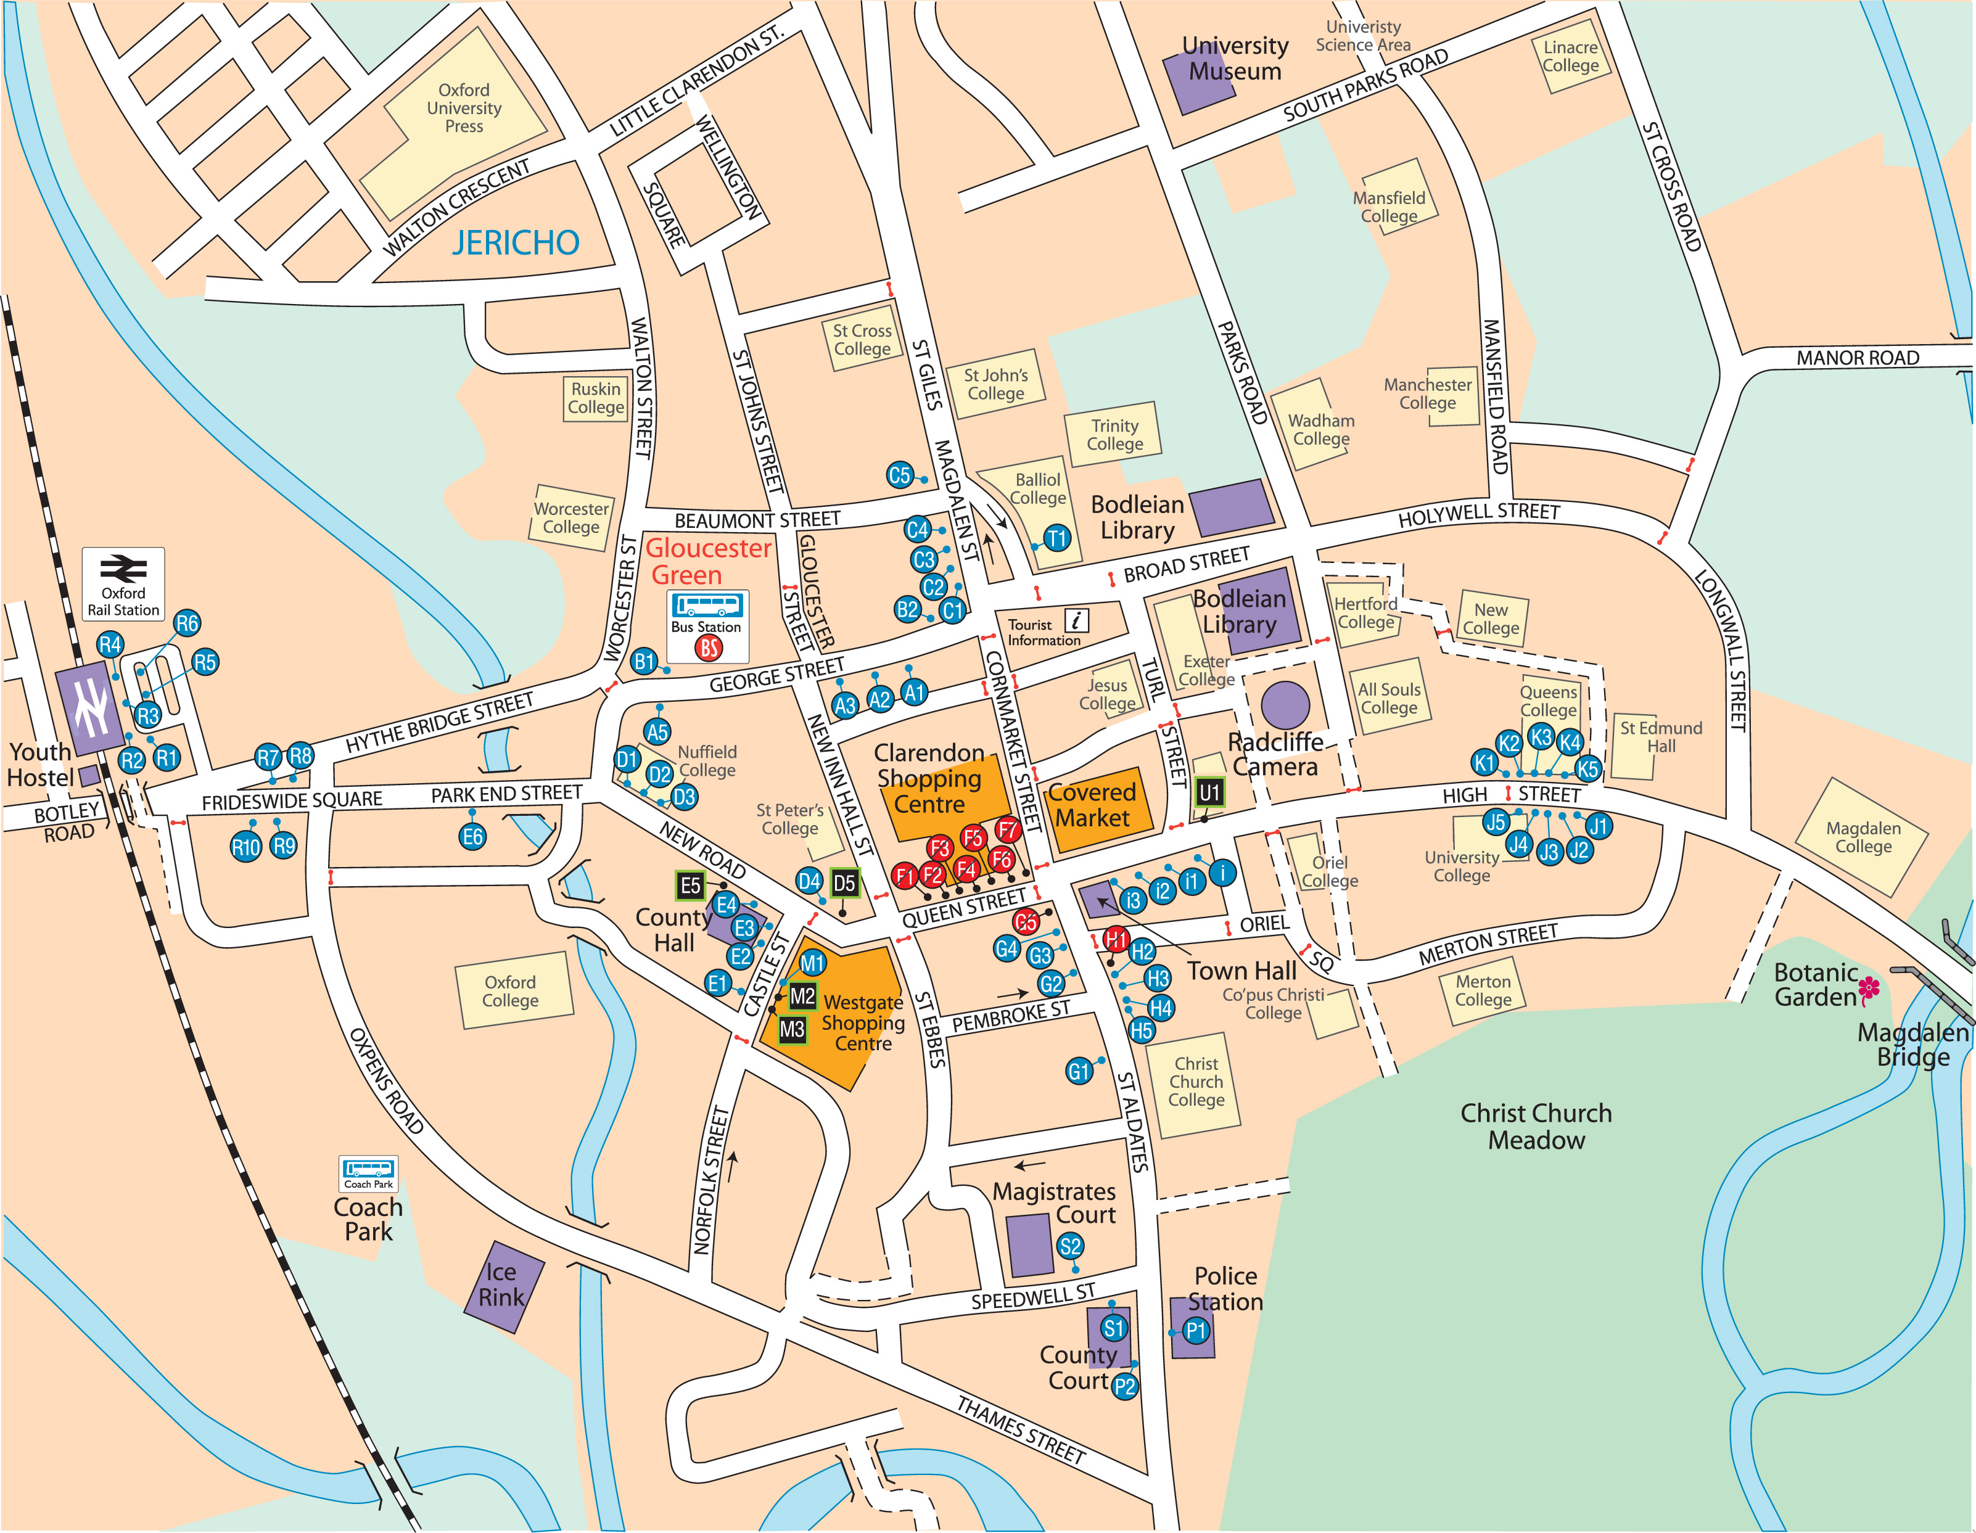

© Oxfordshire County Council 100023343 2009

